INDIAN INSTITUTE OF TECHNOLOGY

KHARAGPUR

APPLIED COMPUTATIONAL METHODS LABORATORY

Lab -5

Rajiv Harlalka

20MA20073

Department of Mathematics

Gauss Seidel Method Without red black coloring

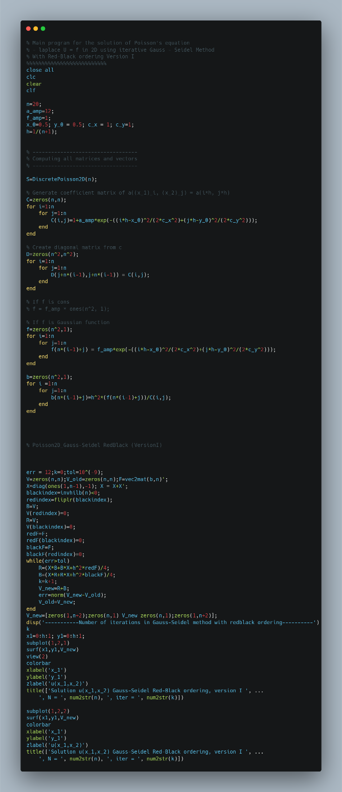

Code:

Output

-----------Number of iterations in Gauss-Seidel method without redblack ordering----------

k = 665

Gauss Siedel Method with red black ordering version 1

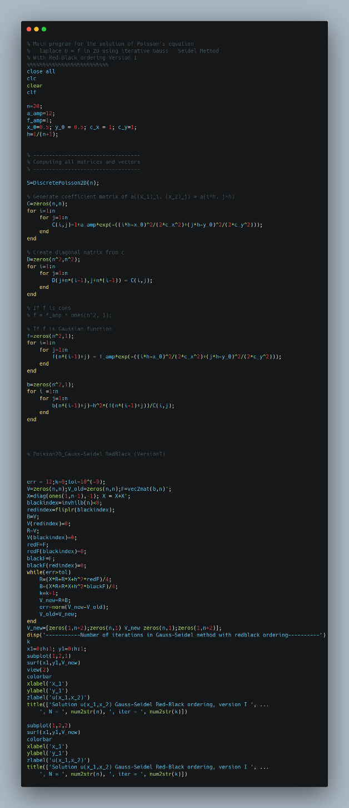Code

Output:   
-----------Number of iterations in Gauss-Seidel method with redblack ordering----------

k = 363

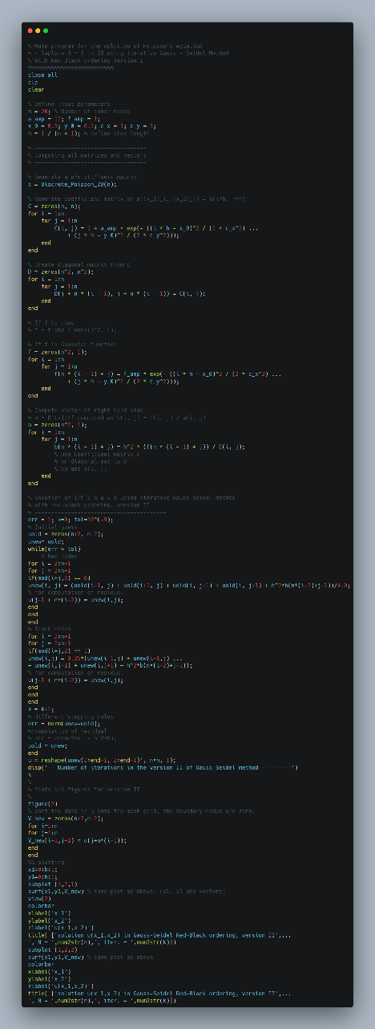Gauss Seidel Method With Red Black ordering Version 2

Code

Output:

-- Number of iterations in the version II of Gauss-Seidel method----------

k = 363